DGMD E-70 Principles of Game Design: Introduction to Unity3D Jason Wiser

- Unity3D Interface
- Unity3D Concepts
- Quick Intro Project:
- Terrain Creation, Textures, Trees
- 3rd-Person Controller
- Introduction to C# Scripting
- Sounds

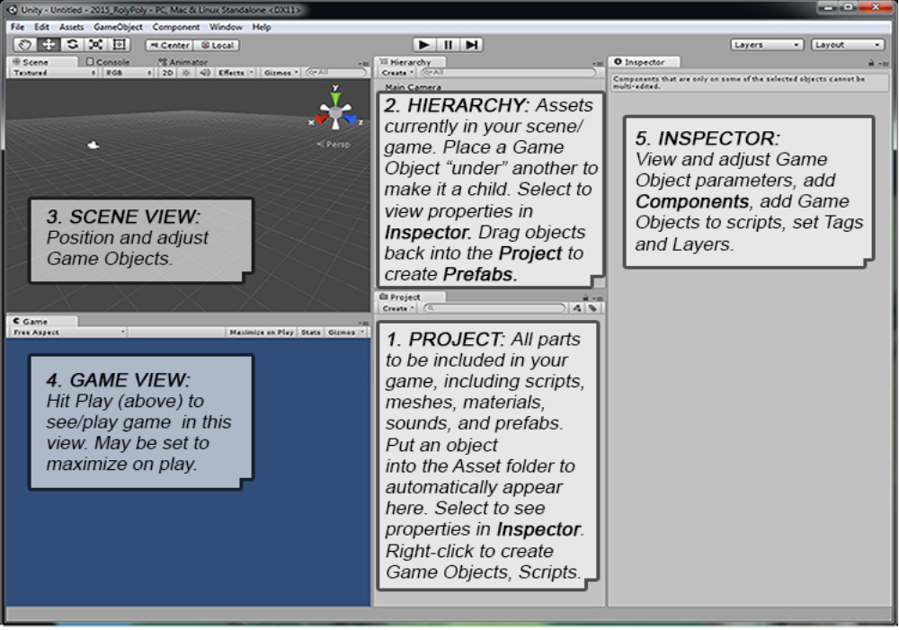
UNITY3D: INTERFACE:

MENU: offers easy access to all aspects of the program. In particular, note:
- File/Build Settings (to start any project)
- Edit/Project Settings/Input for helpful script-controlling inputs.
- Assets/Import Package to import useful prefabs
- GameObject and Component menus for easily building custom assets

SCENE View: View and transform all assets in the game from any desired angle. Orbit=[Alt]+LeftMouse, Pan=[Alt]+MiddleMouse, Zoom=[Alt]+RightMouse. Hit[f] to zoom and frame what is selected (“focus”). [Ctrl]+LeftClick to add or remove from selection.

GAME View: See through camera. Multiple cameras can split screen by percentages. Hit Play to view/ play game. Be careful: changes to assets during Play mode are reset when play is turned off (not saved).

CONSOLE Window: For checking errors thrown in scripts.

PROJECT Window: Where all assets are stored. Directly linked to the actual Project folder, will automatically update if anything is put into or taken out of the folder outside or inside Unity. Only change the contents of the Assets folder. Organize assets into subfolders: prefabs, scripts, etc.

HIERARCHY Window: Contents of the current scene. Organize by parenting similar objects under a named Empty Game Object, like putting all user interface GUIText objects under an Empty G.O. called “UI”.

INSPECTOR: Shows all Components and parameters for whichever G.O. is selected in the Hierarchy (instances) or Project (prefabs).

Context gears: All Components have a gear or other context-sensitive button for changing parameters (like material Shaders) or adding assets, like texture PNGs.

Script Editor: Visual Basic (Unity 5.2 and above) or MonoDevelop (Unity 5.1 and earlier). Access by DoubleClicking a script. Write Unity scripts in either C# or Javascript, but never mix the two in the same script (ideally, avoid mixing in the same game). Scripts are Components added to G.O.s.

SCRIPTING NOTES:
- Add component/Script (C# default) or RightClick Project window to Create/C# Script
- Scripts easily access Components on their GO (RigidBody Mass, Drag, Gravity, etc).
- Unity won’t play game if script has error. See Console or footer for error messages.
- Select a term and hit [Ctrl/Cmd]+[‘] to access documentation.
- Mathf = super useful math functions collection, including clamp.

UNITY3D : MAJOR CONCEPTS / TERMS:

- Game Object: The base of a thing in Unity. Just about every thing in the game starts as an empty G.O., to which we add components to build it into the interactive asset we desire.
- Component: everything we add to Game Objects to make them function as desired, including renderer, materials, particles, audio, physics, and custom scripts. Components can most easily be added to G.O.s and have their settings adjusted in the Inspector, with the G.O. selected.
- Scene: a game “level”. A game can have many Scenes, each sharing or with their own G.O.s, Controllers, and prefabs. File/New Scene to create a new Scene for an existing Project, File/New Project to start an entirely new game.
- Prefab: A container for a complete asset (collection of components, settings, and G.O.) used repeatedly in one or more Scenes. Can even be exported to use in other games. Create by dragging asset from Hierarchy to Project window. Each copy in game is an “instance”. Prefabs can be instantiated by code in a game (bullets, etc.).
- Physics: in Unity there are a number of components to manage physical interactions. Colliders (capsule, mesh, or box) manage object interactions and can be set for physics interactions (bouncing) or to trigger other effects (like activating a script if set to isTrigger). RigidBody enables the built-in physics engine, is applied to any object with actively interacting colliders (any object with a collider that is not the ground), and contains gravity which can be turned off for flying/space games.
- Controller: a component meant to manage a major part of the game. We write a custom GameController for a Scene and add an AnimationController to animated assets to manage the interaction of that asset’s animations with its scripts.
- 2D vs 3D: a 3D Unity game works with perspective and a 2D game uses flat parallax planes. Each must use their own physics prefabs, for example “RigidBody” for 3D and “2DrigidBody” for 2D.
- AUDIO in Unity comes in 3 main forms:
  - Audio Clips = Sound files (see Inspector for import settings/play preview. Flat game: Turn off 3D Sound)
  - Audio Sources = G.O. with audio component to play SFX or music, added by dragging audio clip on G.O. Note “Play on Awake” and “Loop” settings to decide if audio starts immediately as G.O. is created and if it plays continuously. Also note volume settings.
  - Audio Listener = What the audience hears. By default on the Main Camera, the single G.O. that receives audio. If 3D sound is on, distance of Sources from Listener changes audio volume.
- GUITEXT are empty G.O. with GUIText components applied. They are visible only in Game view, not Scene. Uses pixels in viewport space. Position by default is relative to: lowerLeft 0/0/0, upperLeft 1/0/0, upperRight 1/1/0, lowerRight 0/1/0.
- TAGS are identifiers which can be added to a G.O in the Inspector for scripts to exclude or include from an effect, or to find a specific tagged G.O., like the Player or GameController (both defaults)

UNITY 3D: Quick Intro Project
SHORTCUTS:
- Doubleclick on an item in the hierarchy to center it.
- [alt]+ mouse buttons to navigate in the Scene window.
1. Create a new Project with these imported packages: (1) Character Controller, (2) Skyboxes, (3) Terrain Assets (not mobile), (4) Tree Creator. Leave “Setup for” at 3D.
2. Create Terrain: Game Object/3D Object /Terrain. Doubleclick in Hierarchy to center. In Inspector/Terrain(Script), hit the rigthmost button (gear) for Terrain properties. Set width= height= 100 (down from 2000). Doubleclick in Hierarchy to center.
3. Add Lights: gameObject/Lights/Directional Light for the Sun (intensity= 0.8, color=white-yellow, softshadows strength=0.3, rotate towards terrain) and Point Light for the bounce (intensity= 0.3, color=white-blue, no shadows, position below terrain and off to a side, set range=200).
4. Edit Terrain:
- Hit first three buttons in the row of Terrain tools in the Inspector to change Terrain shape, sculpting upwards (or hold [shift] to push downward).
- Set brush size and opacity low and experiment.
- Use tool #2 to set a higher base value (50.0) and hit "flatten" to allow the molding of rivers downward. Also makes clean paths.
- Paint Brush: add textures (hit “Edit Textures/Add Texture”, drag a PNG into the slot, set x and y =1, and hit [Add]).
> Texture #1: automatically applied everywhere
> texture #2: paint in details
5. Add Trees: hit the trees button option and go to [edit trees], hit hot-button and add the default “BigTree” from the TreeCreator/Trees Asset folder.
6. In the Project, Add a CharacterController/FirstPersonController to the scene, lift the capsule above the ground, and hit Play to move around (WASD to move, move mouse to look/turn).

Introduction to scripting and audio: C# structures:
MonoDevelop = script editor. Select code and [Ctrl]+[‘] for manual help.
Comment selected lines: [Ctrl]+[alt]+[c]

Create a cube: GameObject/3D Object/Cube. In the Inspector, hit Add Component and add a Physics/RigidBody, turn on “Is Kinematic”. Add a Physics/Box Collider.

Add a Script: Right-click in Project, choose Create/C# Script. Name it “Rotator.” Double-click in the Project to open in MonoDevelop script editor. “void Start ()” and “void Update ()” are default methods. Delete Start, change class name to Rotator, and add to Update:

public class Rotator : MonoBehaviour {
void Update () {
transform.Rotate (new Vector3 (15, 30, 45) * Time.deltaTime);
}
}

Drag script onto cube. Drag cube into Project to create a Prefab, and [Ctrl] +[d] in Hierachy to duplicate for three cubes. Hit Play.

To the First Person Controller/Graphics G.O.: add Capsule Collider (set to “isTrigger”). Set Tag to “Player”. Move Capsule Collider forward on Z. Add this method to the Rotator script:

public class Rotator : MonoBehaviour {
void Update () {
transform.Rotate (new Vector3 (15, 30, 45) * Time.deltaTime);
}

void OnTriggerEnter(Collider other) {
if (other.gameObject.tag == "Player"){
gameObject.SetActive(false);
}
}
}

Add sound to cube prefab in Project, turn off “Play on Awake”. Change OnTriggerEnter code:

void OnTriggerEnter(Collider other) {
if (other.gameObject.tag == "Player"){
//gameObject.SetActive(false);
audio.Play();
}
}

Remove the sound from the prefab and add different sounds to each cube instance in the Hierarchy. Turn off “Play on Awake” on each. Play, hit each and make 3 different sounds.

